## Effect of Nutrition and Exercise Incentive on Weekly Weight Loss Samantha Bothwell | December 11th, 2020

### **Introduction**

Individuals who classified as overweight or obese were enrolled into the study to understand factors that contribute to weight loss. Participants were separated into two groups. One group had a nutritionist, and the other group did not. Both groups received free access to the Wellness center at the University of Colorado Anschutz Medical Campus. This study is ongoing so we do not have access to intervention groupings. Participants were asked to step on a bluetooth scale once a day over the course of the study. Within the study, there are 3 cohorts. These cohorts indicate participants who started the study around the same time.

The research questions of interest are :

* What is the trajectory of weight over the duration of time in the study?
* Is there a significant decrease in weight over the course of the study, regardless of intervention group?

### **Methods**

#### **Data Cleaning**

The data received was fairly cleaned for prior analysis. One subject in Cohort 2 was missing Age, Sex, Race and Ethnicity information and was removed. Some participants tried to measure weight once a week. We summarized weight as the average weight each week in the study. One participant had > 80% missing data and was removed. To analyze trajectories over a year, we truncated the data to 365 days. This allows for some consistency as cohorts had different lengths of measurement time. The outcome measure for analysis was defined as weekly weight difference from baseline.

#### **Data Analysis**

Data cleaning and visualization will be performed in R, version 4.0.2 (The R Foundation, Vienna University). Longitudinal modeling will be performed in SAS 9.4 (SAS Institute Inc., Cary, NC, USA).

To understand the trajectory of weight over the duration of time in the study we will use the fpca.sc method for regular data in the R refund package, version 0.1-21. We will summarize the results of the mean trajectory for each cohort.

To assess if there is a significant decrease in weight over the course of the study, we will fit a linear mixed model in SAS with PROC MIXED. The model will adjust for baseline weight. Since time points are equally spaced, we will use an AR(1) covariance structure. The model will include a random intercept for participant.

Summaries for categorical variables will be represented as N(%) and continuous variables will be represented as Median [Range] and Mean (95% CI). P-values will be computed using a Kruskal Wallis test for continuous variables and a Chi-Square test for categorical variables.

### **Results**

Table 1, below, displays the cohort characteristics at baseline stratified by enrollment cohort. Of the 90 participants in the study, 69 are female and 21 are male. The average age for Cohort 3 is slightly higher than cohorts 1 and 2, mean 43.6 years compared to 41.8 and 41.5 years for Cohorts 1 and 2 respectively. In effect, the average baseline weight is highest for Cohort 3. For analysis, we are truncating data to 1 year, or 365 days. However, Cohort 3 is still collecting data so this cohort has less than a year of data, 181 days on average.

***Table 1. Cohort Characteristics***

|  | **Cohort 1 (N=29)** | **Cohort 2 (N=25)** | **Cohort 3 (N=36)** | **P-Value** |
| --- | --- | --- | --- | --- |
| **Age** |  |  |  |  |
| Mean (SD) | 41.8 (9.36) | 41.5 (10.5) | 43.6 (8.30) | 0.881 |
| Median [Min, Max] | 43.2 [26.1, 55.8] | 43.1 [21.9, 55.2] | 42.7 [21.8, 54.9] |  |
| **Sex** |  |  |  |  |
| Female | 21 (72.4%) | 19 (76.0%) | 29 (80.6%) | 0.739 |
| Male | 8 (27.6%) | 6 (24.0%) | 7 (19.4%) |  |
| **Race** |  |  |  |  |
| Asian | 0 (0%) | 1 (4.0%) | 4 (11.1%) | 0.0338 |
| Black | 0 (0%) | 3 (12.0%) | 4 (11.1%) |  |
| White | 26 (89.7%) | 21 (84.0%) | 28 (77.8%) |  |
| Other | 3 (10.3%) | 0 (0%) | 0 (0%) |  |
| **Ethnicity** |  |  |  |  |
| Hispanic or Latino | 4 (13.8%) | 3 (12.0%) | 10 (27.8%) | 0.21 |
| Non Hispanic or Latino | 25 (86.2%) | 22 (88.0%) | 26 (72.2%) |  |
| **Baseline Weight** |  |  |  |  |
| Mean (SD) | 214 (32.5) | 210 (40.2) | 220 (31.7) | 0.281 |
| Median [Min, Max] | 210 [166, 285] | 200 [158, 297] | 219 [147, 304] |  |
| **Time Span** |  |  |  |  |
| Mean (SD) | 547 (92.8) | 412 (71.7) | 181 (27.7) | <0.001 |
| Median [Min, Max] | 593 [210, 600] | 431 [84.0, 433] | 186 [41.0, 202] |  |

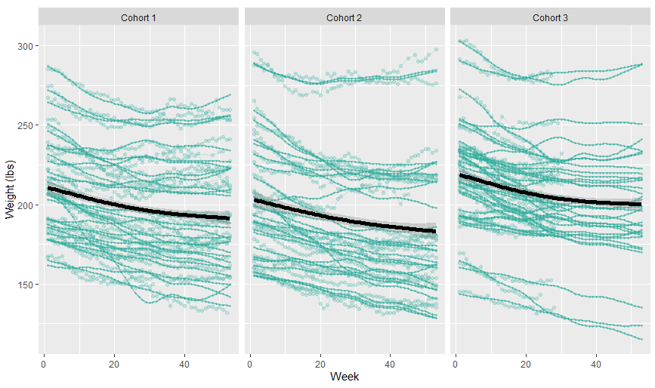Figure 1 shows the actual weights vs the smoothed FPCA line for all individuals in their respective cohort. From the curves, there is a general decline in weights over time. The mean trajectories for cohorts 1 and 2 are fairly comparable. The mean trajectory is higher for cohort 3 than the other two cohorts, indicating that this group had higher weights on average. A reason for this could be that cohort 3 was sampled during the Covid-19 pandemic, while the cohorts 1 and 2 were sampled prior to the pandemic. All three mean trajectory lines follow a similar pattern. As time increases, the slope of the line tends to flatten. The FPCA method fills in missing data from full data trends. For cohort 3 the subjects do not have data after day 200, but FPCA fills in data for the rest of the year to show what they expect the trajectory to be for these subjects.

***Figure 1. Weight Trajectories over time***

**Note:** Reference levels - Cohort = 3, Sex = Male, Race = White

***Table 2. Linear Mixed Model Effect Estimates (AIC = 13187.6)***

|  |  |  |  |  |  |
| --- | --- | --- | --- | --- | --- |
| **Effect** | **Estimate** | **Standard Error** | **DF** | **t Value** | **Pr > |t|** |
| **Intercept** | -2.4539 | 2.0944 | 83 | -1.17 | 0.2447 |
| **Cohort** |  |  |  |  |  |
| Cohort 1 | -0.3520 | 1.0376 | 3195 | -0.34 | 0.7345 |
| Cohort 2 | -1.1756 | 1.0196 | 3195 | -1.15 | 0.2490 |
| **Sex = Female** | 1.5819 | 0.9173 | 3195 | 1.72 | 0.0847 |
| **Age** | 0.0341 | 0.0420 | 3195 | 0.81 | 0.4177 |
| **Race** |  |  |  |  |  |
| Asian | 0.2497 | 1.7671 | 3195 | 0.14 | 0.8876 |
| Black/African American | 2.0379 | 1.4871 | 3195 | 1.37 | 0.1706 |
| Other | -1.5341 | 2.2165 | 3195 | -0.69 | 0.4889 |
| **Week** | -0.9943 | 0.0757 | 87 | -13.13 | <.0001 |
| **Week*Week** | 0.0153 | 0.0008 | 3195 | 19.59 | <.0001 |
| **Week*Cohort 1** | -0.1125 | 0.1050 | 3195 | -1.07 | 0.2843 |
| **Week*Cohort 2** | -0.1797 | 0.1093 | 3195 | -1.64 | 0.1003 |

Table 2 represents the summary output from the linear mixed model. Based on the output, the variables that have a significant relationship with weight are Sex, Race, Days in Study and Month. Females weigh, on average, 29.7 lbs less than males (p=0.0001). An Asian participant weighs, on average, 35.1 lbs less than a White participant (p=0.0147). For every additional day in the study, a participant is expected to weight 0.06 lbs less, on average (p<0.0001). Compared to the month of December, participants weigh significantly less in August, October and November (maybe December is feeling the effects of Turkey season). In August, participants weigh, on average, 1.1 lb less than in December (p=0.0051). In October, participants weigh, on average, 0.7 lbs less than in December (p=0.0224). In November, participants weigh, on average, 0.6 lbs less than in December (p=0.0032). There is a significant overall effect of month in

|  |  |  |  |  |
| --- | --- | --- | --- | --- |
| **Effect** | **Num DF** | **Den DF** | **F Value** | **Pr > F** |
| **Cohort** | 2 | 3195 | 0.70 | 0.4983 |
| **Sex** | 1 | 3195 | 2.97 | 0.0847 |
| **Age** | 1 | 3195 | 0.66 | 0.4177 |
| **Race** | 3 | 3195 | 0.79 | 0.4992 |
| **Week** | 1 | 85 | 348.97 | <.0001 |
| **Week * Week** | 1 | 3195 | 383.66 | <.0001 |
| **Week * Cohort** | 2 | 3195 | 1.40 | 0.2470 |

the model (Num DF = 11, Den DF = 752, F = 2.8, p = 0.0014).

***Table 3. Type 3 Tests for Fixed Effects***

# **Code Appendix**

/* 13162.9 */

**PROC** **MIXED** DATA = wt_week ;

CLASS participant_id cohort sex race(ref = "5");

MODEL weight_change = cohort sex age race Week Week*Week cohort*Week / solution outp = pred1;

RANDOM INTERCEPT / subject = participant_id;

RANDOM Week / subject = participant_id;

/* RANDOM month / subject = participant_id; */

REPEATED / SUBJECT = participant_id type=ar(**1**);

**RUN**;

/* 13160.2 */

**PROC** **MIXED** DATA = wt_week ;

CLASS participant_id cohort sex race(ref = "5");

MODEL mean_wt = weight_bs cohort sex age race Week Week*Week / solution outp = pred2;

RANDOM INTERCEPT / subject = participant_id;

RANDOM Week / subject = participant_id;

/* RANDOM month / subject = participant_id; */

REPEATED / SUBJECT = participant_id type=ar(**1**);

**RUN**;